**FUNCTION PACKAGE**

CREATE OR REPLACE PACKAGE taxes_pkg IS

FUNCTION tax (p_value IN NUMBER) RETURN NUMBER;

END taxes_pkg;

/

CREATE OR REPLACE PACKAGE BODY taxes_pkg IS

FUNCTION tax (p_value IN NUMBER) RETURN NUMBER IS

v_rate NUMBER := 0.08;

BEGIN

RETURN (p_value * v_rate);

END tax;

END taxes_pkg;

/

SELECT taxes_pkg.tax(salary), salary, last_name FROM employees;

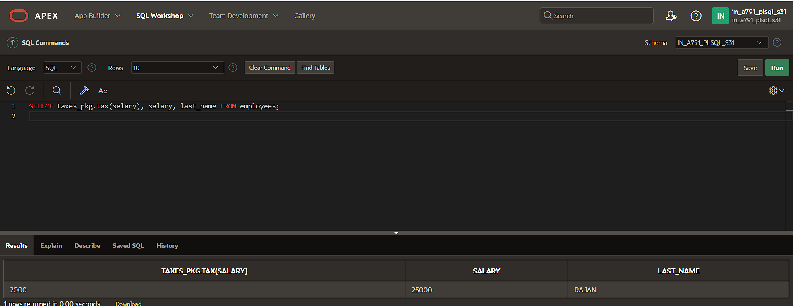

**RECORD PACKAGE**

CREATE OR REPLACE PROCEDURE sel_one_emp (

p_emp_id IN employees.employee_id%TYPE,

p_emprec OUT employees%ROWTYPE

)

IS

BEGIN

SELECT *

INTO p_emprec

FROM employees

WHERE employee_id = p_emp_id;

EXCEPTION

WHEN NO_DATA_FOUND THEN

WHEN OTHERS THEN

RAISE_APPLICATION_ERROR(-20001, 'Unexpected error occurred: ' || SQLERRM);

END sel_one_emp;

/

DECLARE

v_emprec employees%ROWTYPE;

BEGIN

sel_one_emp(100, v_emprec);

IF v_emprec.employee_id IS NOT NULL THEN

dbms_output.put_line('Last Name: ' || v_emprec.last_name);

ELSE

dbms_output.put_line('No data found for the given employee ID.');

END IF;

EXCEPTION

WHEN OTHERS THEN

dbms_output.put_line('An unexpected error occurred: ' || SQLERRM);

END;

/

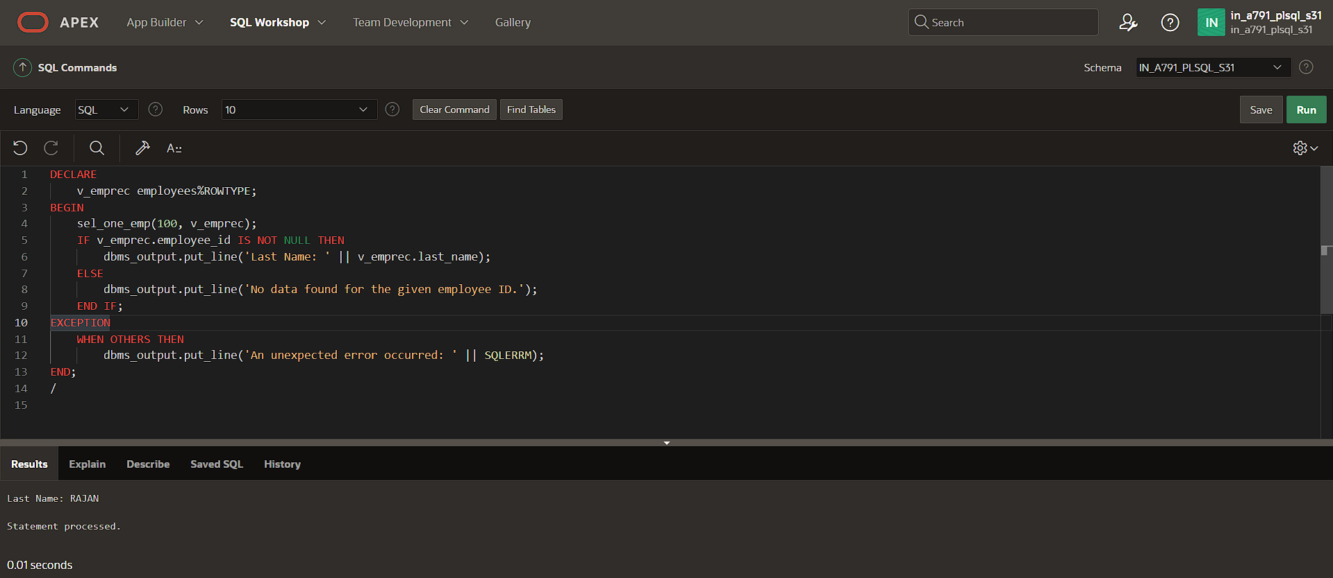

**USER-DEFINED PACKAGE**

CREATE OR REPLACE PACKAGE emp_dept_pkg

IS

TYPE ed_type IS RECORD (

f_name employees.first_name%TYPE,

l_name employees.last_name%TYPE,

d_name departments.department_name%TYPE

);

PROCEDURE sel_emp_dept (

p_emp_id IN employees.employee_id%TYPE,

p_emp_dept_rec OUT ed_type

);

END emp_dept_pkg;

/

CREATE OR REPLACE PACKAGE BODY emp_dept_pkg

IS

PROCEDURE sel_emp_dept (

p_emp_id IN employees.employee_id%TYPE,

p_emp_dept_rec OUT ed_type

)

IS

BEGIN

SELECT e.first_name, e.last_name, d.department_name

INTO p_emp_dept_rec.f_name, p_emp_dept_rec.l_name, p_emp_dept_rec.d_name

FROM employees e

JOIN departments d ON e.department_id = d.department_id

WHERE e.employee_id = p_emp_id;

EXCEPTION

WHEN NO_DATA_FOUND THEN

p_emp_dept_rec.f_name := NULL;

p_emp_dept_rec.l_name := NULL;

p_emp_dept_rec.d_name := NULL;

WHEN OTHERS THEN

RAISE_APPLICATION_ERROR(-20001, 'Unexpected error occurred: ' || SQLERRM);

END sel_emp_dept;

END emp_dept_pkg;

/

DECLARE

v_emp_dept_rec emp_dept_pkg.ed_type;

BEGIN

emp_dept_pkg.sel_emp_dept(100, v_emp_dept_rec);

dbms_output.put_line('First Name: ' || v_emp_dept_rec.f_name);

dbms_output.put_line('Last Name: ' || v_emp_dept_rec.l_name);

dbms_output.put_line('Department Name: ' || v_emp_dept_rec.d_name);

EXCEPTION

WHEN NO_DATA_FOUND THEN

dbms_output.put_line('No data found for the given employee ID.');

WHEN OTHERS THEN

dbms_output.put_line('An unexpected error occurred: ' || SQLERRM);

END;

/

